DOCTOR APPOINTMENT MANAGEMENT

A Project Report

*Submitted by*

STUDENT-1 O.Lokeshwar Reddy-AP23110011150

STUDENT-2 K.Sri Akshaya-AP23110011163

STUDENT-3 K.Sumana Sree-AP23110011203

STUDENT- 4 Mehrosh Sultana-AP23110011212

STUDENT-5 R.Phani Sree-AP23110011213

***Under the Supervision of***

**Mr. B. L. V. SIVA RAMA KRISHNA  
Assistant Professor  
Department of Computer Science and Engineering  
SRM University-AP**

*In partial fulfilment for the requirements of the Web Technology (CSE210) Project*

**BACHELOR OF TECHNOLOGY  
IN  
COMPUTER SCIENCE AND ENGINEERING**



**DEPARTMENT OF COMPUTER SCIENCE AND ENGINEERING**

**SRM UNIVERSITY-AP**

**NEERUKONDA**

**MANAGALAGIRI - 522503**

**ANDHRA PRADESH, INDIA**

**APRIL-2025**

**CERTIFICATE**

This is to certify that the project work entitled **“Doctor Appointment System”** is a Bonafide record of project work carried out by the following students:

* **Mr. O.Lokeshwar Reddy** (Roll No.: AP23110011150)
* **Ms. K.Sri Akshaya**  (Roll No.: AP23110011163)
* **Ms. K.Sumana Sree** (Roll No.: AP23110011203)
* **Ms. Mehrosh Sultana**  (Roll No.: AP23110011212)
* **Ms. R.Phani Sree** (Roll No.: AP23110011213)

from the **Department of Computer Science and Engineering, SRM University-AP.** The students conducted this project work under my supervision during the period **January 2025 to April 2024**.It is further certified that, to the best of my knowledge, this project has not previously formed the basis for the award of any degree or any similar title to this or any other candidate.

This is also to certify that the project work represents the **teamwork** of the candidates.

Station: Mangalagiri **Mr. B. L. V. Siva Rama Krishna**

Date: 25-04-2025 Assistant Professor  d **Department of Computer Science & Engineering**

SRM University-AP  
 Andhra Pradesh.

**TABLE OF CONTENTS**

|  |  |  |
| --- | --- | --- |
| **S. NO.** | **TITLE** | **PAGE NO.** |
| 1 | Introduction | 4 |
| 2 | Problem Definition | 5 |
| 3 | Problem Statement | 6 |
| 4 | Objectives | 7 |
| 5 | Software Requirements Specifications | 8 |
| 6 | Design (DFD Diagram) | 9 |
| 7 | Implementation | 10 |
| 8 | Database Design | 11 |
| 9 | Output Screenshots | 14 |
|  |  |  |
|  |  |  |

**Introduction**

In today’s fast-paced digital world, the integration of technology into healthcare services has become more important than ever.

The primary objective of this system is to simplify the appointment scheduling process for both doctors and patients. It eliminates the traditional, time-consuming methods of booking appointments by providing a streamlined, user-friendly interface where users can view doctor availability, book slots, and receive confirmations instantly.  
This project uses web technology concepts of Web Technology like HTML, CSS, JAVASCRIPT, PHP

At BOOK CONSULTATIONS we provide all patient comfort at fingertips.

If a person prefers to go to the hospital and get a prior offline appointment, they can do that using this website. Otherwise, if a person cannot visit the hospital, then they can freely proceed with the online consultations.

If you forgot to purchase the medicines after getting a prescription, then you have an option to order it right from your home or wherever you maybe.

Sometimes, prior appointment helps save the waiting time, so you can book your lab tests for the offline mode and visit the hospital at the given time.

If you have to get small tests done (which maybe done at home CONDITIONS APPLY), you can get them done at home.

**This system bridges the gap between traditional healthcare and digital convenience.**  
**Our goal is to make healthcare accessible, time-efficient, and patient-centric through smart web solutions.**

**Problem Definition**

In the normal healthcare system, booking appointments is usually time-consuming and inefficient, requiring waiting in long queues or making repeated calls. Usually, many receptions are needed if the hospital is a big one. Also, even after waiting in long queues, if the doctor is not available for that time, it gets very difficult and frustrating for patients, often resulting in wasted time and effort. This unpredictability in scheduling further adds to the inconvenience, especially for those who are unwell or elderly.  
Additionally, people in remote areas or with busy schedules face difficulties accessing timely medical care. Sometimes a word with the doctor is enough to get cure. If a person is living far and wants to consult a specific doctor, he/she has to travel long and spend more on travel expenses, room rents and hospital fees.   
Small lab tests which do not need complicated and big machinery can be done at home, but we usually do not have an option for that. Also, an option to schedule lab-test prior to reaching the hospital is really comfortable and convenient.   
Sometimes we may forget to purchase the medicines prescribed or it may not be currently available, in such cases we have to visit the hospital multiple times just for the medicines.   
These gaps highlight the need for a digital solution that simplifies and streamlines the entire process. The Doctor Appointment Management System addresses these issues by offering a centralized, web-based platform for managing appointments, consultations, and related services.

**Problem Statement**

The traditional healthcare system is inefficient, with long queues, limited doctor availability, and no streamlined way to book appointments, tests, or consultations. Patients, especially those in remote areas or with busy schedules, face delays and inconvenience due to the lack of a centralized digital solution. Also, the medicines purchasing needs to be done easier.

**Objectives**

* To develop a user-friendly, web-based platform for booking doctor appointments easily and efficiently.
* To reduce waiting time and improve appointment scheduling by providing real-time doctor availability.
* To offer online consultation options for patients unable to visit hospitals physically.
* To enable users to book lab tests in advance and provide the option for home sample collection (where applicable).
* To integrate an online medicine ordering feature for patient convenience.
* To improve overall healthcare access and reduce manual dependency through digital automation.

**Software Requirements Specifications**

**Software Requirements:**

**Operating System:** Windows 10 / Linux / macOS

**Frontend:** HTML, CSS, JavaScript

**Backend:** PHP

**Database:** MySQL

**Web Server:** Apache (via XAMPP/WAMP/LAMP)

**Browser:** Google Chrome / Mozilla Firefox / Microsoft Edge

**Code Editor:** VS Code / Sublime Text / Notepad++

**Hardware Requirements:**

**Processor:** Dual Core or higher

**RAM:** Minimum 2 GB (4 GB recommended)

**Storage:** Minimum 500 MB free space

**Display:** 1024x768 resolution or higher

**Internet Connection:** Required for online access and updates

**Design (DFD Diagram)**

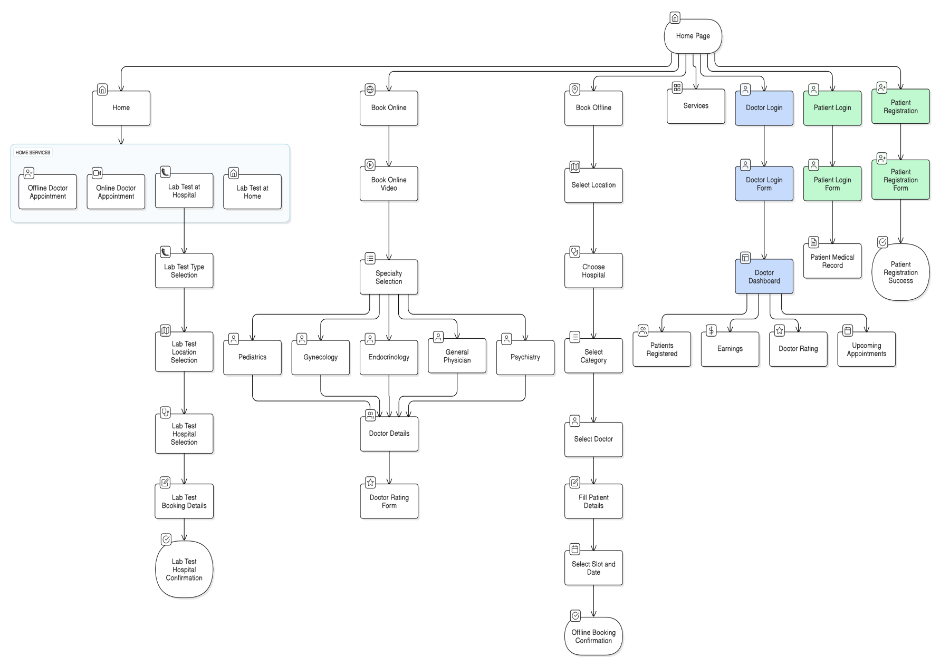

**Implementation**

The project was built using HTML, CSS, JavaScript, PHP, and MySQL.

**a) Frontend Development**

* The user interface was designed using HTML and styled with CSS to ensure responsiveness and ease of use.
* JavaScript was used for client-side logic, such as enabling/disabling time slots, storing selections in localStorage, and handling dynamic interactions.
* Different HTML forms were used for booking appointments, submitting feedback, and searching doctors by department.

**b) Doctor Listing and Filtering**

* When department is selected, it is stored in localStorage and carried to the doctor list page.
* The doctor list page uses JavaScript to filter and display only the doctors that match the selected specialization.

**c) Appointment Booking**

* The booking form collects patient details, doctor name, session, and time slot.
* After submission, the form data is sent via POST to a PHP script, which validates and inserts it into the booking_slots table.
* Upon successful insertion, the user is redirected to a confirmation page.

**d) Rating**

* A feedback form lets users rate the doctor and submit comments. This data is stored in the doctor_ratings table.

**e) Backend Integration (PHP + MySQL)**

* PHP scripts handle form submissions, fetch data from the database, and manage redirections.
* SQL queries were used to insert and retrieve data from tables like booking_slots, offline_appointments, doctordetails, and doctor_ratings.

**Database Design**

**Database name:-** hosipital_application

**Table 1:-** patient

|  |  |
| --- | --- |
| id | int |
| patient_name | varchar(50) |
| email | varchar(50) |
| phone | varchar(20) |
| language | varchar(50) |
| password | varchar(10) not null |
| gender | enum |
| age | int not null |
| blood_group | enum |

**Table 2:-** hospital_labbookings

|  |  |
| --- | --- |
| id | int |
| Patient_name | varchar(50) |
| test_type | varchar(50) |
| hospital | varchar(100) |
| date | date |

**Table 3:-** doctordetails

|  |  |
| --- | --- |
| id | int |
| name | varchar(50) not null |
| email | varchar(30) not null unique |
| password | varchar(10) not null |
| phone_number | varchar(15) |
| language | varchar(15) |
| profession | varchar(50) |
| qualification | varchar(100) |
| experience | varchar(50) |
| address | varchar(255) |
| mode | enum |

**Table 4:-** offline_appointments

|  |  |
| --- | --- |
| id | int |
| location | varchar(60) not null |
| hospital | varchar(50) not null |
| department | varchar(40) not null |
| doctor | varchar(30) not null |
| slot | varchar(15) not null |
| patient_name | varchar(50) not null |
| age | int |
| phone | varchar(15) |
| appointment_date | date |

**Table 5:-** booking_slots

|  |  |
| --- | --- |
| id | int |
| p_name | varchar(50) not null |
| p_age | int not null |
| session | varchar(50) |
| slot_time | time not null |
| doctor_name | varchar(50) not null |
| department | varchar(30) |
| created_at | TIMESTAMP |

**Table 6:-** doctor_ratings

|  |  |
| --- | --- |
| id | int |
| doctor_name | varchar(50) not null |
| rating | int not null |
| feedback | varchar(100) |
| created_at | TIMESTAMP |

**Table 7:-** home_lab_bookings

|  |  |
| --- | --- |
| id | int |
| fullname | varchar(50) not null |
| contact | varchar(15) not null |
| testname | varchar(40) not null |
| testprice | decimal(10,2) not null |
| date | date not null |
| time | time not null |
| address | varchar(255) not null |

**Table 8:-** prescriptions

|  |  |
| --- | --- |
| appointmentID | int |
| patient_name | varchar(50) not null |
| doctor_name | varchar(50) not null |
| appointment_date | date |
| medicines | text |
| instructions | varchar(200) |
| created_at | TIMESTAMP |

**Output Screenshots**

 